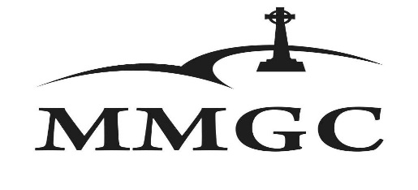

Ryder Cup

19 – 21 November 2021

Sponsor/ Team Name: ______________________________________________________

Team Contact Person: ______________________________________________________

 |  |  |  | Shirt Size
Player Name | Email | Contact Number | H/Cap Index | (S-XXXL)

The entry fee for all golfers includes the following:

- Free Practise Round Friday 19 Nov 2021
- Black Tie Dinner Friday 19 Nov 2021
- Entertainment and dinner Saturday 20 Nov 2021
- Halfway meals for both Saturday and Sunday Rounds 20 & 21 Nov 2021
- Prize Giving snacks Sunday 21 Nov 2021
- Ryder Cup 2021 Shirt
- Goody Bag

Non-golfers (partners of golfers & sponsors) who would like to join us for the Friday night black tie dinner or the Saturday night dinner & entertainment, are welcome to do so at R250 per person per dinner. Bookings are essential! Please indicate:

Non-golfers for Friday night’s black-tie dinner
Non- golfers for Saturday night’s entertainment dinner
_____________ persons

_____________ persons

The full programme will be emailed to you closer to the event.

Entries close 8 Nov 2021! We will not take responsibility for changes in your team after the entries have closed.

Your entry will only be confirmed once we have received your completed and signed entry form accompanied with the proof of payment. Please send your entry form and proof of payment to cygnature@mmge.co.za or golf@mmge.co.za

Fee: | R6800 per four-ball
Account Name: | Magersfontein Memorial Golf Club
Bank: | Standard Bank
Account Number: | 041 697 685
Branch Code: | 050002
Reference: | Team Name
Signature: _____________________________ |  | Name: ____________________________
Company: ____________________________ |  | Date: ______________________________

